Cottage Flowers is a survey of seven standard species found in classic English cottage gardens. These old-fashioned flowers can be found in most perennial gardens and are cherished by gardeners around the world. Their origins as wildflowers are still evident in their vigorous qualities, but their cultivation has given them charm and sophistication, while keeping their whimsical and friendly natures. In composing Cottage Flowers, the composer drew upon his childhood experiences in the garden, having grown each species represented at his rural Wisconsin farm. When planning for college, the composer considered music and botany equally, and although choosing composition as a career, still gardens as a life-long hobby. Using this intimate knowledge of these plants and their “personalities,” each movement has its own narrative, as seen in the “Composer’s Note” which follows a botanical description.

- Alcea (Hollyhock)
- Dianthus (Sweet William)
- Digitalis (Foxglove)
- Lavendula (Lavender)
- Leucanthemum (Daisy)
- Polygonatum (Solomon’s Seal)
- Primulacea (Primrose)
Alcea (Hollyhock)
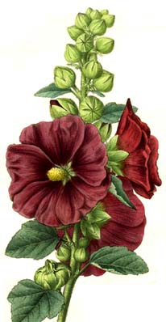
Alcea rosea - Hollyhocks are old garden favorites. This mix of singles features plants which produce huge (4-5" diameter), outward-facing, single flowers in a wide variety of colors including reds, pinks, whites, and light yellows. The flowers grow on rigid, towering spikes or spires which typically reach a height of 5-8' tall and usually do not require staking. Foliage features large, heart-shaped (3, 5 or 7 lobes), rough lower leaves which become progressively smaller toward the top of the spire. Hollyhocks provide excellent architectural height, contrast and a certain amount of old world charm to cottage gardens and border backgrounds. Also effective when grown against walls or fences.

Composer’s Note: After growing so tall, the hollyhock sways gently in the breeze, its crumpled flowers being equally stodgy and whimsical. Each stalk bobs up and down with a sense that is awkward but oddly graceful.
Dianthus (Sweet William)
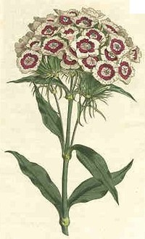
Dianthus barbatus - This is a short-lived perennial that is perhaps best grown as a biennial. However, many gardeners simply purchase cold treated plants in spring and grow them as annuals. Moreover, many of the new cultivars will bloom the first year from seed if the seed is started early enough. Sweet William is best grown in deep, organically rich, well-drained soils in full sun, but generally appreciates some light afternoon shade in hot summer climates. In optimum growing conditions it will reseed each year and remain in the garden for many years as if it were a long-lived perennial. Double-flowered forms will not come true from seed, however.

Composer’s Note: Highly textured, a bit old-fashioned, but still energetic. Acting truly as a multi-generational plant, the older flowering portions of the plant chide the younger sprouts for their rebellious adventurousness.

Digitalis (Foxglove)
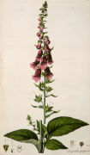
Digitalis purpurea - This biennial produces only a basal rosette of light green, oblong leaves in the first year, but the flowers that borne in the second year line the 2-4’ tall spires with long, tubular, funnels that are dark rose-pink to purple (sometimes white) with purple and white spots on the inside. The flowers are attractive to hummingbirds, but the plant leaves are highly poisonous. Individual flowers resemble the snipped off fingers of a glove, hence the common name of foxglove. The tall spires provide striking color and good architectural height to a border and are particularly effective in front of dark backgrounds such as those provided by a wall or shrubs and are also effective in woodland gardens or naturalized areas.
Composer’s Note: The mysterious drone-like singing of fairies floats from one bell of the foxglove flower to the next, inviting the listener into a magical world filled with surprises – a mirage hiding in the dappled light of the woodlands.
Lavendula (Lavender)
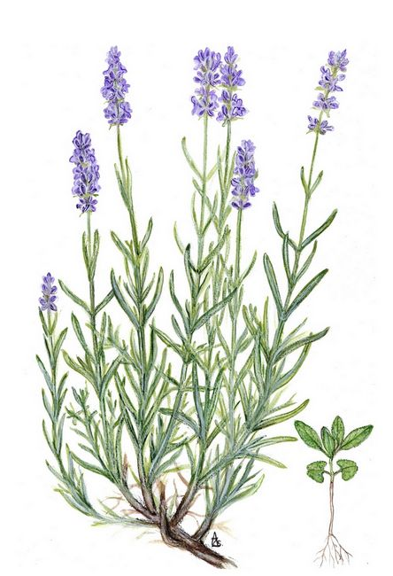
Lavendula angustifolia - English lavender has been a mainstay of herb gardens for many years. Despite its common name, it is not native to England, but comes primarily from the Mediterranean region. It was reportedly named English lavender because of its ability to grow well in the English climate. This “true lavender” is commercially planted for harvesting its oils for use in perfumes and also are popular additions to sachets and potpourris. Purple flowers appear in terminal spikes in late spring to early summer above light green leaves, which remain green in warm winter climates.

Composer’s Note: The exotic fragrance of lavender conjures up images of the Mediterranean and the Near East, but its scent can be a double-edged sword. At times, it fills the nostrils with warmth and luxury, but breathe too deeply and you are bound to sniffle and sneeze.
Leucanthemum (Daisy)
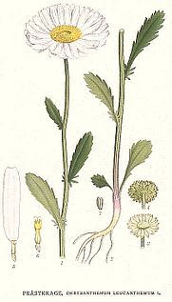
Leucanthemum vulgare - Commonly known as oxeye daisy or marguerite, it is an erect, somewhat weedy, rhizomatous perennial that typically grows to 3’ tall. Although native to Europe, this is the common white daisy that has naturalized in fields, pastures, roadsides and waste areas throughout North American. Blooms in mid-spring to early summer. Toothed, spatulate to obovate, dark green basal leaves (to 5” long). Smaller stem leaves are often pinnatifid. Excellent and long-lasting fresh cut flower. Common name is in reference to the flower’s large flattened center disk, which purportedly resembles the eye of an ox. Oxeye daisies provide long-lasting bloom and are valued additions to the perennial border, cottage garden, wild garden, cutting garden, naturalized areas, and meadows.
Composer’s Note: Like all members of the daisy family, this cheerful flower shines brightly, whether in sun or shade, but is too often subjected to its fateful death in the lover’s game of “She Loves Me, She Loves Me Not.”
Polygonatum (Solomon’s Seal)

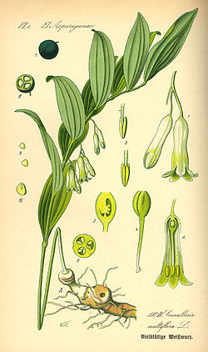
Polygonatum odoratum - Commonly called fragrant Solomon's seal, is a rhizomatous, shade-loving perennial that typically grows to 18-24” tall on low, gracefully arching, angled, unbranched stems. It is native to shaded slopes and woodland areas in temperate regions of Europe and Asia, and Polygonatum biflorum is a North American relative. The leaves turn an attractive yellow in fall and the greenish-white tubular flowers have a sweet, lily-like fragrance but transform into drooping blue-black berries. In Greek poly means many and gonu means knee joint, referring to the jointed plant rhizomes but the common name may refer either to the large, circular seals located on the rhizomes or the plants “wound sealing properties.”
Composer’s Note: The gentle dangling flowers have a regal and refined appearance, yet mysterious and distant, as if trapped in a reverie. But suddenly, the plant’s quiet sophistication gives way to an aggressive and almost comical row of blue-black berries.

Primulacea (Primrose)
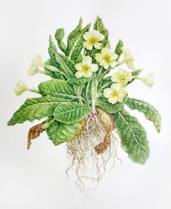
Primula vulgaris - An herbaceous perennial plant, low growing, to 10–30 cm tall, with a basal rosette of leaves, small flowers borne singly on a slender stem. Wild primroses are pale yellow, white, red, or purple, with hybrids available in a wide range of colours, such as pink. The wild primrose was once a common sight in Victorian cottage gardens. It flowers in early spring, one of the earliest spring flowers in much of Europe. The name "Primrose" is ultimately from Old French primerose or medieval Latin prima rosa, meaning first "rose". In appropriate conditions, it can cover the ground in open woods and shaded hedgerows.

Composers Note: The ambitious hardiness of the primrose emerges in a processional. The plant develops through variations, at first distant and quiet as the leaves poke through the cold ground, followed by stems and buds, and finally its full flowering and fragrance. Reminiscent of Ravel’s “Bolero” the graceful beauty of spring’s roses come from the primordial nothingness of winter.

